Google Finance Download

# Documentation

## Purpose

The purpose of this program is to download and reformat trade data from Google Finance.

## Operation

### Installation

Download the two files GoogleFinanceDownload.exe and GoogleFinanceDownloader.dll. The program can be run from any folder that has permissions to run an executable file (.exe). I recommend putting it into a folder where you will be saving the data.

### Run the Program

Double click the program and the single dialog box will appear.

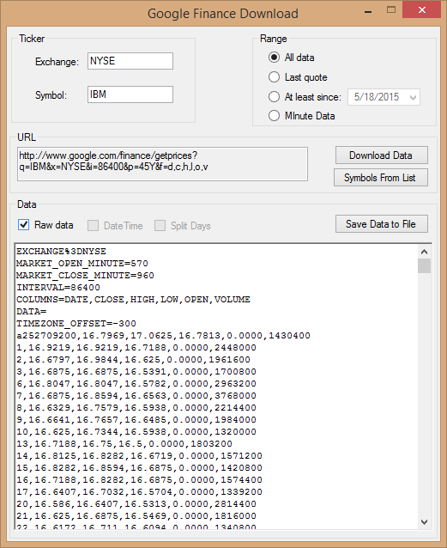

### Inputs

1. Exchange – (optional) If you know where the security is traded, and Google Finance has it, you can enter it here. For common stocks, EFTs, and indices, the exchange will be assumed. However, if you fill in the exchange a folder will be created when you download a list of securities from a file
2. Symbol – (required) the symbol for the security you are requesting.
3. Range – (defaults to All) The range of data you are requesting from Google Finance.
   1. All – gets all available daily data for the Symbol.
   2. Last quote – gets the DateTime, open, high, low, close and volume for the last trade made today.
   3. At least since – gets the daily data from the date in the text box up to today.
   4. Minute Data – gets minute trade bars for the last 15 days, the maximum that Google Finance allows.
4. Data – this large text area show a list of the data returned from Google Finance.
   1. Save – This button saves the data displayed in the text area to a comma separated values file. The format of the data saved is what you see in the text area. A standard FileSaveDialog box allows you to specify where and to what name you want to save the data file. The default is the folder where the application is running.  
      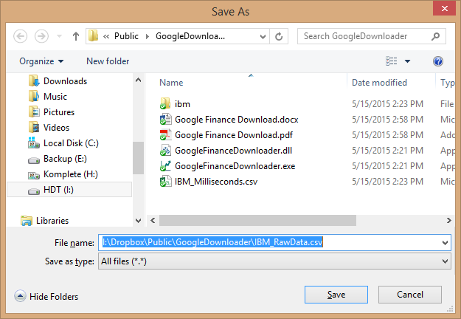
   2. Raw Data – Checking this box displays the data just as it was returned from Google Finance including the header rows.
   3. DateTime/Milliseconds – This check box is only enabled when the Minutes radio button is selected. Checking this box shows the minute data in either Date format (yyyy-mm-dd hh:mm:ss) or Milliseconds since midnight of the day.   
        
      The default is DateTime which can be parsed directly into a Microsoft DateTime object (at least in C# and VB). Many languages accept and recognize this date format and can convert it into the language specific Date and Time object.   
        
      Toggling the checkbox changes it to Milliseconds. Milliseconds are counted from midnight for each day, so the first number in a day where the market opens at 9:30 Eastern Time Zone (GMT – 5hrs) will be something like 34320000 and the last will be something like 34440000 at 4:30. This is the format that Quant Connect expects when reading back testing data from a file.
   4. Split Days – This check box is only enabled when the Minutes radio button is selected. Checking this box will split each day’s data into a separate file in a sub folder to the one selected for saving. This convention is what Quant Connect expects.   
        
      Splitting the data into separate day files is also handy when saving with milliseconds because the first column only shows the milliseconds and not the date. If multiple days are in the download, it saves you from having to guess where the day is split. With DateTime (unchecked), the date and time are displayed in column 1, but you still might have to guess or inspect the data to see where the day’s trading breaks.
5. Download Data – This button downloads the data from Google Finance and displays it in the large text area. If the text area is blank, you need to click this button so that the Save button is enabled.
6. Symbols From List – This button takes the symbols from a list created from a csv file located in the program execution directory. There are three such files provided by downloading from <http://www.nasdaq.com/screening/companies-by-industry.aspx?sortname=symbol&sorttype=0&exchange=NASDAQ> . The lists are for the NYSE, AMEX and NASDAQ exchanges. It is helpful if you put the name of the exchange in the Exchange text box.
   1. The files are downloaded into a directory structure of {root}\{exchange}\{symbol_first_letter}\{ticker}\{yyyymmdd}_trade.csv  
      For example, C:\GoogleDownloads\NYSE\A\aa\20150501_trade.csv.
   2. Each ticker symbol is downloaded for the last 15 days, the max Google allows the first time you click the button and it can take some time depending upon your network connection.
   3. On subsequent runs, the program checks to see if the file already exists and, if so, does not download it again. It can still take some time, but is much faster because the program does not ask google for the unnecessary data.
   4. If you run the program during the trading day, it will still download whatever data is available for the day. The data will be shorter because not all of it will be available because the trading day is not over and there might be some delay from Google Finance. *You should download the current day again after trading hours + 15 minutes.* The current day’s file will be overwritten with the new data.
7. Save Data to File – You can save the data currently displayed in the Data text box. You will be prompted as to where to save it. The default is the program’s execution directory + the symbol.
   1. If the Minutes radio and Split days check box are checked, it will split additionally split the data into day files as was discussed in Section 4d.
8. URL – This display area shows you the exact url that was sent to Google Finance to get the data. You might need to copy it and paste it into another application such as a browser.